***SMB-A Capstone Project Report – BUSML 7249***

***WOSU Donor Database Analysis and Segmentation***

***by Shyni David***

**Introduction**

WOSU’s primary source of funding comes from individual community support. With over 27,000 donors providing annual support equaling approximately $4 million with additional major and planned gift support, the development team seeks to develop a deeper understanding of our constituency.

Currently, the development teams work out of multiple databases and static documents with a treasure trove of disparate data about their donors. From analytics needs assessment, WOSU is at the base level of analytics and need to lay the foundation in order to further utilize our data for targeted fundraising approaches, but also to eventually build toward predictive modelling of future WOSU donors.

**Objective**

WOSU’s primary source of funding comes from individuals as donations and additional planned gift support. Their development team is seeking to develop a deeper understanding of the constituencies by using data analytics to explore the past and projecting the future. When donors approach philanthropy, their gifts are thoughtful and has intended purposes and seek a return on their philanthropic investments.

WOSU has a wide variety of fundraising programs through events, radio, TV, web, emails and personal contact. Which of these tasks contribute to increased giving? Which tasks detract from the fundraising success? What is the spread of the donors across the country? What should the campaign goal be? What are the factors for their success?

The exploratory data analysis will be used to investigate the trends. The statistical tools and techniques will help to interpret the data and build models to increase the predictability, thus help WOSU to be able to interpret their donor base with better understanding and strategically invest their resources in increasing the scalability and sustainability of donations.

**Data**

There are 3 Datasets provided by WOSU:

1. 2000-2009 – 33740 observations (represents First time Donations), 22 variables/attributes
2. 2010-2018- 36361 observations (represents First time Donations), 22variables/attributes
3. Event files – 22 Text files corresponding to some events 2014-2018 with the names and date and other related information.

**Data Analysis**

Selected Variables

1. EnvSalu - Donor Name - Char
2. LetterSalu- Letter Salutation - Char
3. City - Char
4. StateProv - State - Char
5. AcctSts - Account Status - Char
6. OrigGiftDate - Original Gift Month Year - Date
7. OrigGiftAmt - Original Gift Amount - Numeric
8. OrigGiftSrc - Original Gift Source - Char
9. OrigGiftMode - Original Gift Mode – Char
10. SolType - Original Gift Solicitation Type - Char
11. SolMeth - Original Gift Solicitation Method -Char
12. OrigGiftHasPremFlag - Original Gift Has Premium – Char

The following variables are not needed for my analysis.

1. PBS Digital Token
2. Passport Activation Date

Redundant Variables:

1. AcctID - Account ID - Char
2. Zip Code+4 digits
3. SeqName -Sequence Name
4. Addr1 - Address Line1
5. Addr - Address Line 2
6. EmailAddr - Email address
7. OrigGiftPlgType - Original Gift Pledge Type
8. OrigGivingLevelAmt - Original Gift Level Amount
9. **Attribute Information:**

* Donor Name (qualitative)

Name of the donor as a first name and Last name.

* Letter Salutation (qualitative)

Salutation to individual donors with prefix as Mr. or Mrs. and Organization names.

* City(qualitative)

The data spans around many states in US and territories.

* State (qualitative)

* Account Status (qualitative)

The statuses are expired, contributor and active.

For example, if the first gift was on April 2, 2004, it will be in the Original Gift 2000-2009 file.  People/organizations who stop giving are considered as expired.  People/organizations who are still donating are considered as active/contributor. These files are based on original giving date.

Per Rob Walker, Active member give $60, Contributor gives $59 or less, Expired status refers that the individual or organization is no longer a member.

* Original Gift Month Year (numerical )

The Original giving date for the donor.

* Original Gift Amount(numerical)

The Original donation amount or the donations received for the first time.

* Original Gift Source (qualitative)

Has the detailed information of the event that initiated the donation. Per Rob Walker, TOOP is an internal phrase for a one-off TV pledge drive and can be categorized with TV drives. LAPS is a Lapsed member who has not given in the past 12 months before that gift. Some of the Solicitation descriptions in Original Gift Source can be replaced with the descriptions in the variable Original Gift Solicitation Method.

* Original Gift Mode(qualitative)

This field describes how the payment has been made like by CC, Cheque, Cash or EFT.

* Original Gift Solicitation Type(qualitative)

Generalized description of Solicitation type specially to identify Additional Gifts.

* Solicitation Method (qualitative)
* Original Gift Has Premium (qualitative)

This mean that when the donor made their first gift, they ask for a thank you gift.

Redundant Variables :

* Account ID (qualitative) - This is a unique ID that is randomly assigned when donors make their first donation. These are the people who made their first ever gift in those years.
* Original Gift Level Amount(numerical) -This is the amount of their first gift ever. Is a redundant field.
* Original Gift Pledge Type(qualitative) - This field is same as Solicitation Type
* Sequence Name(qualitative) – This field is same as Donor name.
* Addr1(qualitative) - Address Line1
* Addr(qualitative) - Address Line 2
* Zip code (qualitative)

Zip code + 4 digits(qualitative) - Zip codes were devised entirely for the USPS mailing efficiency. They do not necessarily end at the county line, city line or any political boundary except the national border. The State and the City variables are more informative of the geographical location.

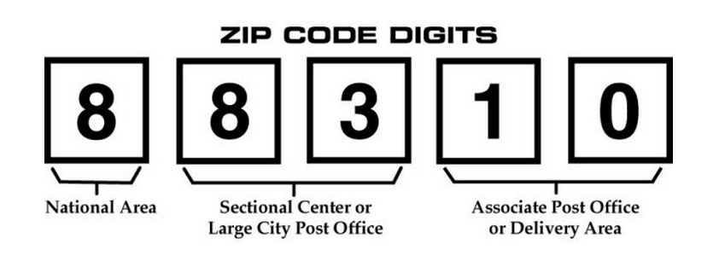

1. **Data Wrangling**

The Exploratory Data Analysis will be segmented for Individuals and organization for in state(OH) and out of state(all other US states).

The Original Gift Data file has to be wrangled for the following:

* + 1. Split Year, Month, Day
    2. Eliminate redundant variables
    3. Lower case for all char fields
    4. Solicitation source mutate to another root word field as a categorical variable.
    5. Split Donor name as first name and last name to link Event file and Original Gift Source.
    6. Mutate the Letter Salutation to create Gender field. Use gender R package.
    7. Identify Organizations with key words as company, group, corporation, foundation, organization, campaign , firm, establishment, agency, office, enterprise, operation, institution, venture, undertaking, practice, society, league, club, network etc. And keep the set of observations as a separate file.
    8. The State variable has data that spans across many states in US and territories . Ohio is the exceptional contributor so will consider separately for analysis from the rest of states. Will add additional field of Regions and Divisions as a categorical variable.

Additional Information:

Regional divisions used by the United States Census Bureau:

• Region 1: Northeast

• Division 1: New England (Connecticut, Maine, Massachusetts, New Hampshire, Rhode Island, and Vermont)

• Division 2: Mid-Atlantic (New Jersey, New York, and Pennsylvania)

• Region 2: Midwest (Prior to June 1984, the Midwest Region was designated as the North Central Region.)[6]

• Division 3: East North Central (Illinois, Indiana, Michigan, Ohio, and Wisconsin)

• Division 4: West North Central (Iowa, Kansas, Minnesota, Missouri, Nebraska, North Dakota, and South Dakota)

• Region 3: South

• Division 5: South Atlantic (Delaware, Florida, Georgia, Maryland, North Carolina, South Carolina, Virginia, District of Columbia, and West Virginia)

• Division 6: East South Central (Alabama, Kentucky, Mississippi, and Tennessee)

• Division 7: West South Central (Arkansas, Louisiana, Oklahoma, and Texas)

• Region 4: West

• Division 8: Mountain (Arizona, Colorado, Idaho, Montana, Nevada, New Mexico, Utah, and Wyoming)

• Division 9: Pacific (Alaska, California, Hawaii, Oregon, and Washington)

* + 1. The Original Gift source is a huge vital list that has to be transformed to root words for analysis. For modelling this field can be split as dummy variables.
    2. The 22 Event text file has to be combined into one file with variables as First Name, Last name, Event month, Event year, Event day , Event name and Original Gift Source(root word).

Event files : The files have no standard format .

The Invitees are recorded by name, email id, address and other event details. Email ids can change over time but are unique and are not consistent. First and last names can be same as or different than from a first-time giver.

To be consistent with the given event file, I used names and email ids to trace back first time donors with Account ID’s in the Original Gift file.

* + 1. Check for Null Values
    2. Merge the value “Additional Gift” from variable Orig_Gift_Pledge_type into variable Solicitaion_type.

**Results of Data Pre processing**

The list of observations was mainly segmented as Donations from

* Individuals

-From Ohio USA

-Outside Ohio in USA

* Organizations
* Outside US mainland

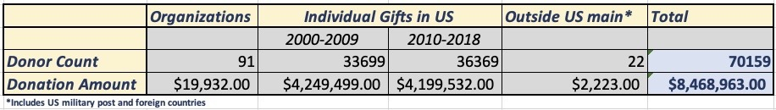

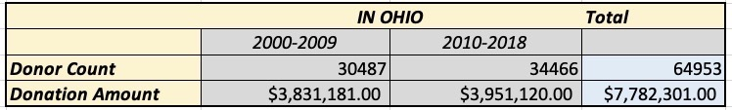

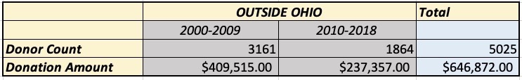

|  |  |  |  |  |
| --- | --- | --- | --- | --- |
| **As given by WOSU** |  |  | |  |
| Gifts from 2000-2009 | 33740 |  | |  |
| Gifts from 2010-2018 | 36361 |  | |  |
|  | 70101 |  |  | |  |
| In ALL |  |  |  | |  |
| Organizations | GOrg_root_03 | 91 | $ 19,932.00 | |  |
| Outside US | Gout_US_02 | 22 | $ 2,223.00 | |  |
| Gifts from 2000-2009 | Gift_00_09_05 | 33699 | $ 4,249,499.00 | | *removed records for year less than 2000 |
| Gifts from 2010-2018 | Gift_10_18_05 | 36369 | $ 4,199,532.00 | |  |
|  | Total | 70090 | $ 8,449,031.00 | |  |
|  |  |  |  | |  |
| In Ohio |  |  |  | |  |
| 2000-2009 | Gift_OH_09 | 30487 | $ 3,831,181.00 | |  |
| 2010-2018 | Gift_OH_18 | 34466 | $ 3,951,120.00 | |  |
|  | Total |  | $ 7,782,301.00 | |  |
|  |  |  |  | |  |
|  | Outside OH |  |  | |  |
| 2000-2009 | Gift_00_09_08 | 3161 | $ 409,515.00 | |  |
| 2010-2018 | Gift_10_18_08 | 1864 | $ 237,357.50 | |  |
|  | Total |  | $ 646,872.50 | |  |



**Explanatory Data Analysis**



**Figure 1**

The Community engagement Events are hosted and advertised by WOSU and relate back to their programming.

Figure 1 is the summarized output of Event attendees from 2014-2018.

Top left chart highlights more attendance of women and in the top right graph, it turns out that more of non-donors are event attendees.

Bottom charts show the variation of event attendees over the years and months.

From 2016 onwards, we see a steady increase in the number of attendees and beginning months of the year seems to be most preferred to attend an event and Year end, the least.

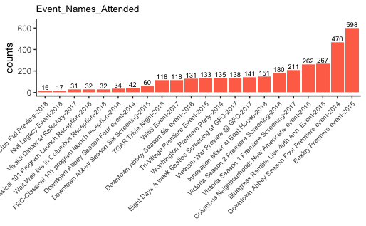

**Figure 2**

The graph in Figure 2 shows various event names and the Year in which they were organized and the count of people who had attended. The maximum number of event attendance was at Bexley Premiere event held in 2015.



**Figure 3**

The top left graph of Figure 3 shows the variation of the count of donors as in the state of Ohio, outside Ohio, Organizations and Outside US( which include remote US military post overseas, US territories and foreign countries.)

The bottom right chart shows the variation of the number of donors in Ohio and the rest of states in US. We see that majority of the donors are concentrated in Ohio.



**Figure 4**

The three graphs in Figure 4 shows a glimpse of the number of donors from various cities in Ohio for a cut off of 100 donors. The number of donors from Columbus Ohio is exceptionally high as 22255.



**Figure 5**

In Figure 5, we see the spread of donors outside of Ohio in US main continent.

The heat map has the color shading in blue with no donors to red in Florida which has the maximum number of donors.

The lighter shades show the scattered donors across the country in eastern, western and southern regions.

The chart shows the donors in various cities and the state, the highest number of donors are from Chicago, IL followed by Huntington, WV and Moreland and Ashland in KY.



**Figure 6**

Donations from “Outside USA “ were very few in number and these are from:

* Remote overseas US military post offices as APO, AEO
* US territories like Virgin Islands and Guam and
* A few from Canada and UK.



**Figure 7**

In Figure 7, we see an expanse of donation in percentages over the years. We see a dip in donation following great recession hit in 2008 and after that relative to the prior 10 years, the percentages of donation have increased.



**Figure 8**

In Figure 8, for Individual Donors , the top left chart shows higher percentage of women contribution to donations.

On the top right chart is the variation in the donation contributions of various Solicitation Methods used by WOSU. On-air is most significant contributor of donations followed by Direct Mail and Web.

Telemarketing, Online and Personal contact’s contribution are very insignificant.

Bottom graph represents the variation of contribution of various Original Source which prompted the actual donations. Radio and TV seems to be the most popular.



**Figure 9**

If the first-time donors continue as Donors, they have Active Status, and Expired means they stopped giving. Active is same as the Contributor, with Contributors used to categorize donors who donate $60.00 or more.

In Figure 9, the overall retention rate of donors is around 26%.



**Figure 9**

Figure 9 displays the comparison of first-time donors various Original Gift Source for both the Active and Expired status of donors.

We see that Passport and Web have apparently higher percentages of donors sustained in active status as compared to donors with expired status.



**Figure 10**

I took the subset of individual donor database with Donation amounts greater than or equal to $500.00 and created a Network visualization with nodes as cities and original gift source as in left hand side network in Fig 10. The weighted scale is the donation amount.

The right-hand side image shows the page rank which highlights the influence of nodes and the scale shows the measure of influence.



**Figure 11**

In Figure 11, the network shows the betweenness centrality which is the maximum number of shortest paths through a focal node. Nodes in critical junction has highest score.

Scale shows the measure and we see radio , TV, special opportunity(like auctions, classical, celebrity shows etc.) have the highest betweenness centrality and of course Columbus city.

The subset can be varied for donation amount to find the relationship between cities and the donation amount.



**Figure 12**

The Data set of 91 organizations which has donated to WOSU are concentrated in Columbus Ohio and the rest are scattered across the country.

Figure 12 displays the Organizations from cities in Ohio and from neighboring states PA, IN, WV and KY, North eastern states of CT, NJ and NY, southern

state of North Carolina and western state of California.

**PREDICTIVE ANALYSIS**



**Figure 13**

vif(model_01x)

## GVIF Df GVIF^(1/(2*Df))

## Gift_Month 1.038470 1 1.019054

## Gift_Year 1.659271 1 1.288127

## gender 1.008058 1 1.004021

## GS_radio 1.564377 1 1.250751

## GS_acquisition 2.416272 1 1.554436

## GS_mail 2.562134 1 1.600667

## GS_otwhite 1.125930 1 1.061098

## GS_specialopportunity 1.331119 1 1.153741

## GS_showcase 1.022389 1 1.011132

## GS_passport 1.461366 1 1.208870

## GS_annfund 1.770882 1 1.330745

## GS_web 1.189039 1 1.090431

## GS_cba 1.076989 1 1.037781

## GS_oa 1.638215 1 1.279928

## SM_autoren 2.141707 1 1.463457

## SM_other 1.888072 1 1.374071

## SM_email 2.207225 1 1.485673

## SM_online 1.000605 1 1.000303

## SM_telemkt 1.011321 1 1.005644

## ST_ren 2.419585 1 1.555502

## ST_exp 1.024167 1 1.012012

## Orig_Gift_Has_Prm 1.977437 1 1.406214

## Account_Status 1.410822 2 1.089853

## Original_Gift_Mode 2.977344 6 1.095181

vif(model_02x)

## GVIF Df GVIF^(1/(2*Df))

## Gift_Month 1.031008 1 1.015386

## Gift_Year 1.656316 1 1.286979

## gender 1.007925 1 1.003955

## GS_radio 1.564695 1 1.250878

## GS_acquisition 2.390836 1 1.546233

## GS_mail 1.046139 1 1.022810

## GS_otwhite 1.125663 1 1.060973

## GS_specialopportunity 1.215166 1 1.102346

## GS_showcase 1.022379 1 1.011128

## GS_passport 1.458467 1 1.207670

## GS_annfund 1.051879 1 1.025612

## GS_web 1.188438 1 1.090155

## GS_cba 1.074893 1 1.036770

## GS_oa 1.629190 1 1.276397

## Orig_Gift_Has_Prm 1.970092 1 1.403600

## Account_Status 1.422845 2 1.092168

## Original_Gift_Mode 2.865592 6 1.091695

## Region 1.298819 1 1.139657

## Division 1.311109 1 1.145037

Prepare Models- US - individuals

*# test run model*

model_01x <- lm(logDonation ~ Gift_Month + Gift_Year + gender + GS_radio + GS_acquisition + GS_mail + GS_otwhite + GS_specialopportunity + GS_showcase + GS_passport + GS_annfund + GS_web + GS_mail + GS_cba + GS_oa + SM_autoren + SM_other + SM_email + SM_online + SM_telemkt + ST_ren + ST_exp + Orig_Gift_Has_Prm + Account_Status + Original_Gift_Mode, data = y_final_02)

summary(model_01x)

##

## Call:

## lm(formula = logDonation ~ Gift_Month + Gift_Year + gender +

## GS_radio + GS_acquisition + GS_mail + GS_otwhite + GS_specialopportunity +

## GS_showcase + GS_passport + GS_annfund + GS_web + GS_mail +

## GS_cba + GS_oa + SM_autoren + SM_other + SM_email + SM_online +

## SM_telemkt + ST_ren + ST_exp + Orig_Gift_Has_Prm + Account_Status +

## Original_Gift_Mode, data = y_final_02)

##

## Residuals:

## Min 1Q Median 3Q Max

## -4.8964 -0.3525 0.0140 0.3703 5.4226

##

## Coefficients:

## Estimate Std. Error t value

## (Intercept) -7.0081733 1.0712519 -6.542

## Gift_Month 0.0000987 0.0006606 0.149

## Gift_Year 0.0059648 0.0005332 11.186

## gendermale 0.0603948 0.0046827 12.897

## GS_radio -0.1902180 0.0057965 -32.816

## GS_acquisition -0.3226847 0.0121805 -26.492

## GS_mail -0.2911717 0.0461618 -6.308

## GS_otwhite -0.0975134 0.0203799 -4.785

## GS_specialopportunity -0.0435735 0.0166084 -2.624

## GS_showcase 0.1197746 0.0350977 3.413

## GS_passport -0.0451882 0.0142576 -3.169

## GS_annfund -1.3652135 0.0573203 -23.817

## GS_web -0.1020502 0.0142248 -7.174

## GS_cba -0.2988349 0.0393956 -7.585

## GS_oa -0.7270538 0.0161091 -45.133

## SM_autoren 0.6925066 0.0974290 7.108

## SM_other 0.5490116 0.0377572 14.541

## SM_email 0.2564596 0.0562901 4.556

## SM_online -0.0640010 0.4313298 -0.148

## SM_telemkt -0.1675603 0.2317950 -0.723

## ST_ren -0.0743424 0.0707914 -1.050

## ST_exp -0.0658655 0.0881914 -0.747

## Orig_Gift_Has_PrmN -0.9802744 0.0066957 -146.404

## Account_StatusActive 0.1398983 0.0062951 22.223

## Account_StatusContributor -0.4175091 0.0152534 -27.372

## Original_Gift_ModeOne time cash -0.1273897 0.0083672 -15.225

## Original_Gift_ModeMonthly Credit Card -0.0173955 0.0083744 -2.077

## Original_Gift_ModeEFT Monthly 0.0834702 0.0186654 4.472

## Original_Gift_ModeQuarterly Credit Card -0.1108337 0.0640496 -1.730

## Original_Gift_ModeEFT one time 0.0429184 0.1096709 0.391

## Original_Gift_ModeSemi Annual Credit Card -0.2225398 0.1198067 -1.857

## Pr(>|t|)

## (Intercept) 6.11e-11 ***

## Gift_Month 0.881228

## Gift_Year < 2e-16 ***

## gendermale < 2e-16 ***

## GS_radio < 2e-16 ***

## GS_acquisition < 2e-16 ***

## GS_mail 2.85e-10 ***

## GS_otwhite 1.72e-06 ***

## GS_specialopportunity 0.008703 **

## GS_showcase 0.000644 ***

## GS_passport 0.001528 **

## GS_annfund < 2e-16 ***

## GS_web 7.35e-13 ***

## GS_cba 3.35e-14 ***

## GS_oa < 2e-16 ***

## SM_autoren 1.19e-12 ***

## SM_other < 2e-16 ***

## SM_email 5.22e-06 ***

## SM_online 0.882043

## SM_telemkt 0.469755

## ST_ren 0.293647

## ST_exp 0.455159

## Orig_Gift_Has_PrmN < 2e-16 ***

## Account_StatusActive < 2e-16 ***

## Account_StatusContributor < 2e-16 ***

## Original_Gift_ModeOne time cash < 2e-16 ***

## Original_Gift_ModeMonthly Credit Card 0.037784 *

## Original_Gift_ModeEFT Monthly 7.76e-06 ***

## Original_Gift_ModeQuarterly Credit Card 0.083557 .

## Original_Gift_ModeEFT one time 0.695549

## Original_Gift_ModeSemi Annual Credit Card 0.063245 .

## ---

## Signif. codes: 0 '***' 0.001 '**' 0.01 '*' 0.05 '.' 0.1 ' ' 1

##

## Residual standard error: 0.6098 on 69947 degrees of freedom

## Multiple R-squared: 0.4861, Adjusted R-squared: 0.4859

## F-statistic: 2206 on 30 and 69947 DF, p-value: < 2.2e-16

vif(model_01x)

## GVIF Df GVIF^(1/(2*Df))

## Gift_Month 1.038470 1 1.019054

## Gift_Year 1.659271 1 1.288127

## gender 1.008058 1 1.004021

## GS_radio 1.564377 1 1.250751

## GS_acquisition 2.416272 1 1.554436

## GS_mail 2.562134 1 1.600667

## GS_otwhite 1.125930 1 1.061098

## GS_specialopportunity 1.331119 1 1.153741

## GS_showcase 1.022389 1 1.011132

## GS_passport 1.461366 1 1.208870

## GS_annfund 1.770882 1 1.330745

## GS_web 1.189039 1 1.090431

## GS_cba 1.076989 1 1.037781

## GS_oa 1.638215 1 1.279928

## SM_autoren 2.141707 1 1.463457

## SM_other 1.888072 1 1.374071

## SM_email 2.207225 1 1.485673

## SM_online 1.000605 1 1.000303

## SM_telemkt 1.011321 1 1.005644

## ST_ren 2.419585 1 1.555502

## ST_exp 1.024167 1 1.012012

## Orig_Gift_Has_Prm 1.977437 1 1.406214

## Account_Status 1.410822 2 1.089853

## Original_Gift_Mode 2.977344 6 1.095181

plot(model_01x) 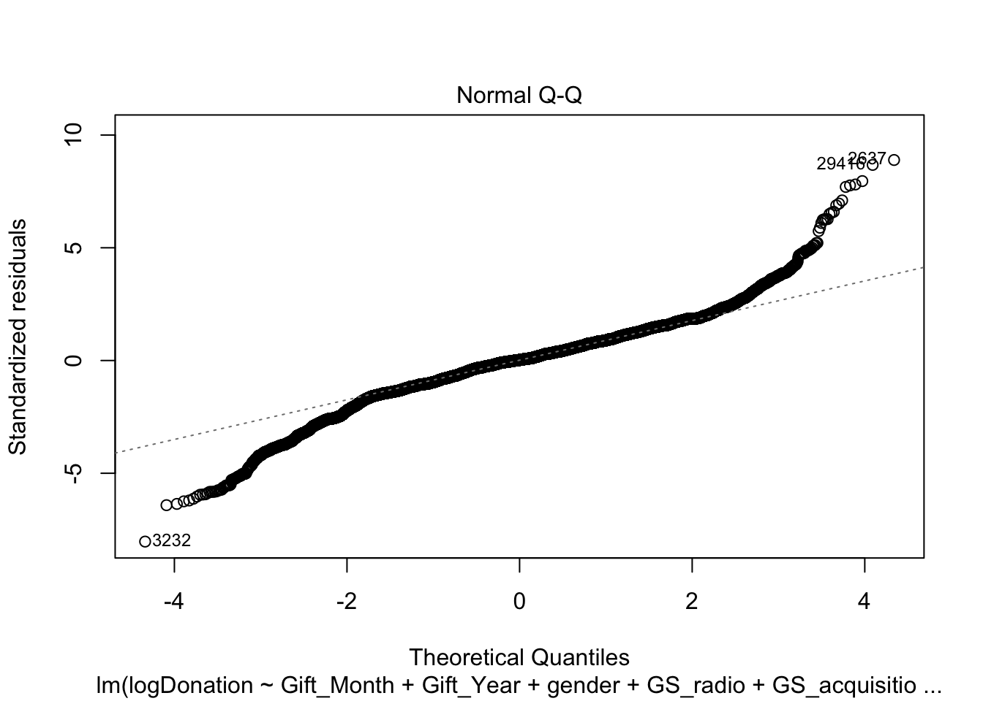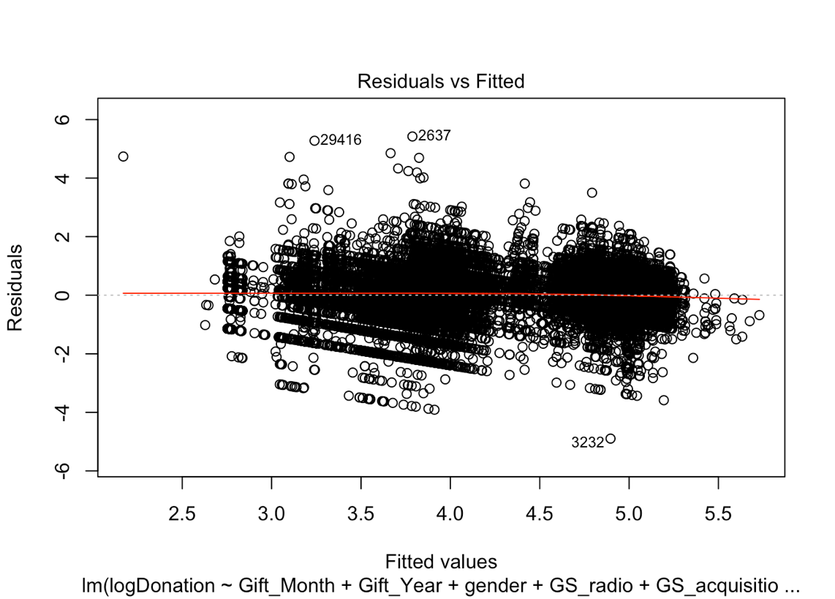

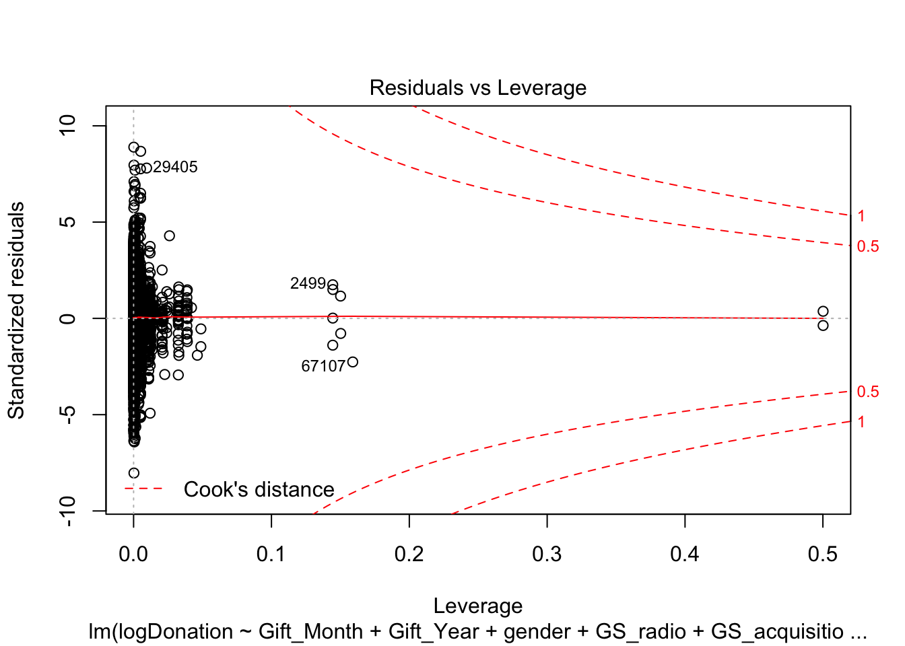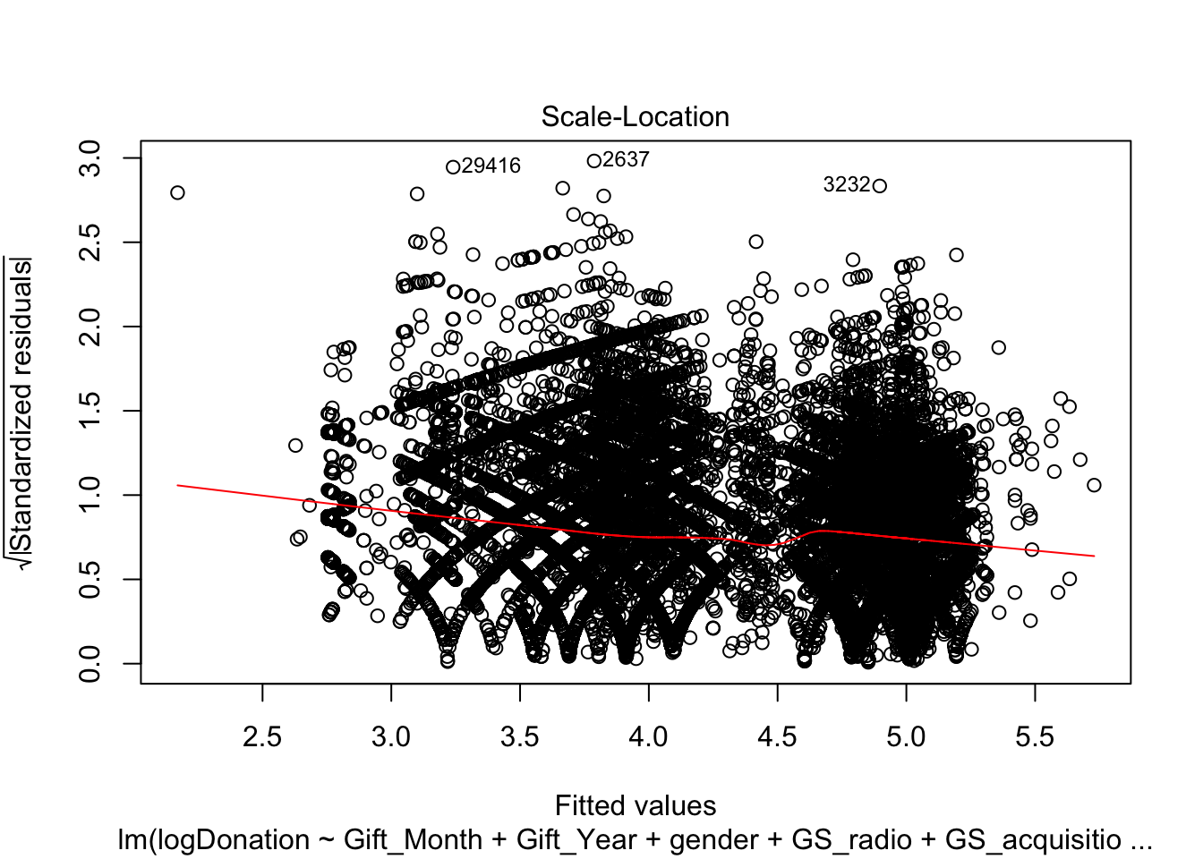

model_02x <- lm(logDonation ~ Gift_Month + Gift_Year + gender + GS_radio + GS_acquisition + GS_mail + GS_otwhite + GS_specialopportunity + GS_showcase + GS_passport + GS_annfund + GS_web + GS_mail + GS_cba + GS_oa + Orig_Gift_Has_Prm + Account_Status + Original_Gift_Mode + Region + Division , data = y_final_02)

summary(model_02x)

##

## Call:

## lm(formula = logDonation ~ Gift_Month + Gift_Year + gender +

## GS_radio + GS_acquisition + GS_mail + GS_otwhite + GS_specialopportunity +

## GS_showcase + GS_passport + GS_annfund + GS_web + GS_mail +

## GS_cba + GS_oa + Orig_Gift_Has_Prm + Account_Status + Original_Gift_Mode +

## Region + Division, data = y_final_02)

##

## Residuals:

## Min 1Q Median 3Q Max

## -4.9407 -0.3528 0.0147 0.3673 5.3554

##

## Coefficients:

## Estimate Std. Error t value

## (Intercept) -7.6532597 1.0728337 -7.134

## Gift_Month 0.0008196 0.0006596 1.243

## Gift_Year 0.0062828 0.0005339 11.767

## gendermale 0.0609452 0.0046927 12.987

## GS_radio -0.1891122 0.0058099 -32.550

## GS_acquisition -0.3343540 0.0121428 -27.535

## GS_mail -0.1760636 0.0295616 -5.956

## GS_otwhite -0.0926373 0.0204222 -4.536

## GS_specialopportunity 0.0180622 0.0159034 1.136

## GS_showcase 0.1240330 0.0351745 3.526

## GS_passport -0.0502266 0.0142747 -3.519

## GS_annfund -0.8326176 0.0442739 -18.806

## GS_web -0.1059161 0.0142524 -7.431

## GS_cba -0.3090147 0.0394436 -7.834

## GS_oa -0.7400077 0.0160999 -45.963

## Orig_Gift_Has_PrmN -0.9771796 0.0066979 -145.894

## Account_StatusActive 0.1408611 0.0063357 22.233

## Account_StatusContributor -0.4188914 0.0152926 -27.392

## Original_Gift_ModeOne time cash -0.1154920 0.0082632 -13.977

## Original_Gift_ModeMonthly Credit Card -0.0142820 0.0083721 -1.706

## Original_Gift_ModeEFT Monthly 0.0885633 0.0186883 4.739

## Original_Gift_ModeQuarterly Credit Card -0.1014617 0.0641772 -1.581

## Original_Gift_ModeEFT one time 0.0448810 0.1099116 0.408

## Original_Gift_ModeSemi Annual Credit Card -0.1623976 0.1199225 -1.354

## Region -0.0141584 0.0103206 -1.372

## Division 0.0133030 0.0033150 4.013

## Pr(>|t|)

## (Intercept) 9.87e-13 ***

## Gift_Month 0.214045

## Gift_Year < 2e-16 ***

## gendermale < 2e-16 ***

## GS_radio < 2e-16 ***

## GS_acquisition < 2e-16 ***

## GS_mail 2.60e-09 ***

## GS_otwhite 5.74e-06 ***

## GS_specialopportunity 0.256067

## GS_showcase 0.000422 ***

## GS_passport 0.000434 ***

## GS_annfund < 2e-16 ***

## GS_web 1.09e-13 ***

## GS_cba 4.78e-15 ***

## GS_oa < 2e-16 ***

## Orig_Gift_Has_PrmN < 2e-16 ***

## Account_StatusActive < 2e-16 ***

## Account_StatusContributor < 2e-16 ***

## Original_Gift_ModeOne time cash < 2e-16 ***

## Original_Gift_ModeMonthly Credit Card 0.088030 .

## Original_Gift_ModeEFT Monthly 2.15e-06 ***

## Original_Gift_ModeQuarterly Credit Card 0.113891

## Original_Gift_ModeEFT one time 0.683027

## Original_Gift_ModeSemi Annual Credit Card 0.175681

## Region 0.170114

## Division 6.00e-05 ***

## ---

## Signif. codes: 0 '***' 0.001 '**' 0.01 '*' 0.05 '.' 0.1 ' ' 1

##

## Residual standard error: 0.6111 on 69952 degrees of freedom

## Multiple R-squared: 0.4838, Adjusted R-squared: 0.4837

## F-statistic: 2623 on 25 and 69952 DF, p-value: < 2.2e-16

vif(model_02x)

## GVIF Df GVIF^(1/(2*Df))

## Gift_Month 1.031008 1 1.015386

## Gift_Year 1.656316 1 1.286979

## gender 1.007925 1 1.003955

## GS_radio 1.564695 1 1.250878

## GS_acquisition 2.390836 1 1.546233

## GS_mail 1.046139 1 1.022810

## GS_otwhite 1.125663 1 1.060973

## GS_specialopportunity 1.215166 1 1.102346

## GS_showcase 1.022379 1 1.011128

## GS_passport 1.458467 1 1.207670

## GS_annfund 1.051879 1 1.025612

## GS_web 1.188438 1 1.090155

## GS_cba 1.074893 1 1.036770

## GS_oa 1.629190 1 1.276397

## Orig_Gift_Has_Prm 1.970092 1 1.403600

## Account_Status 1.422845 2 1.092168

## Original_Gift_Mode 2.865592 6 1.091695

## Region 1.298819 1 1.139657

## Division 1.311109 1 1.145037

plot(model_02x)

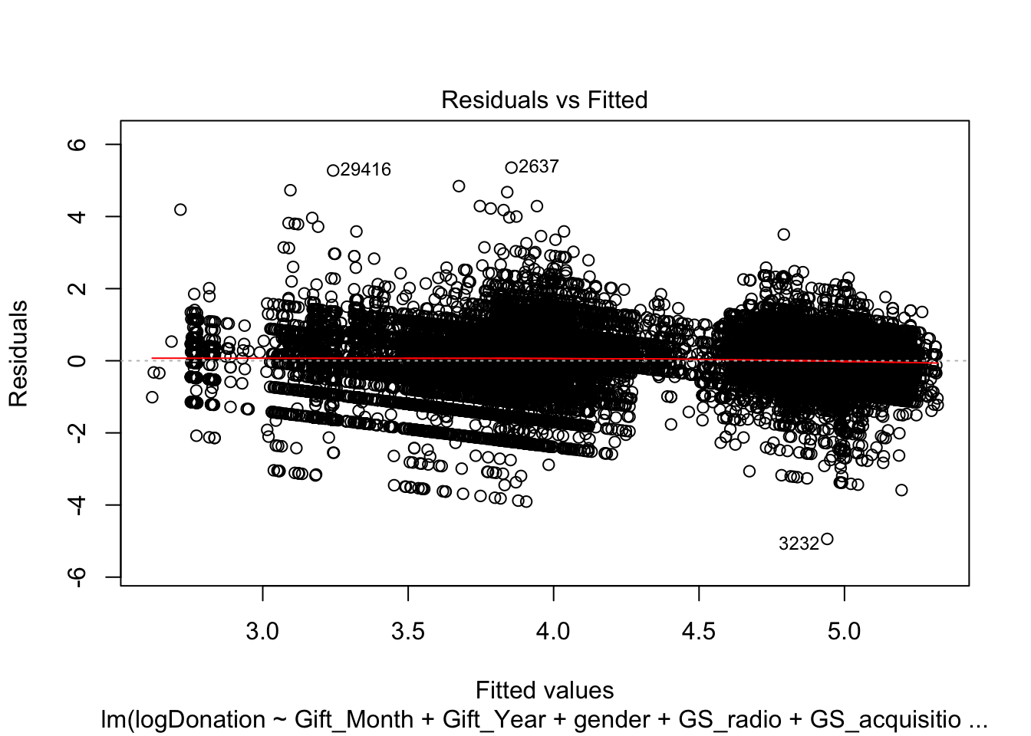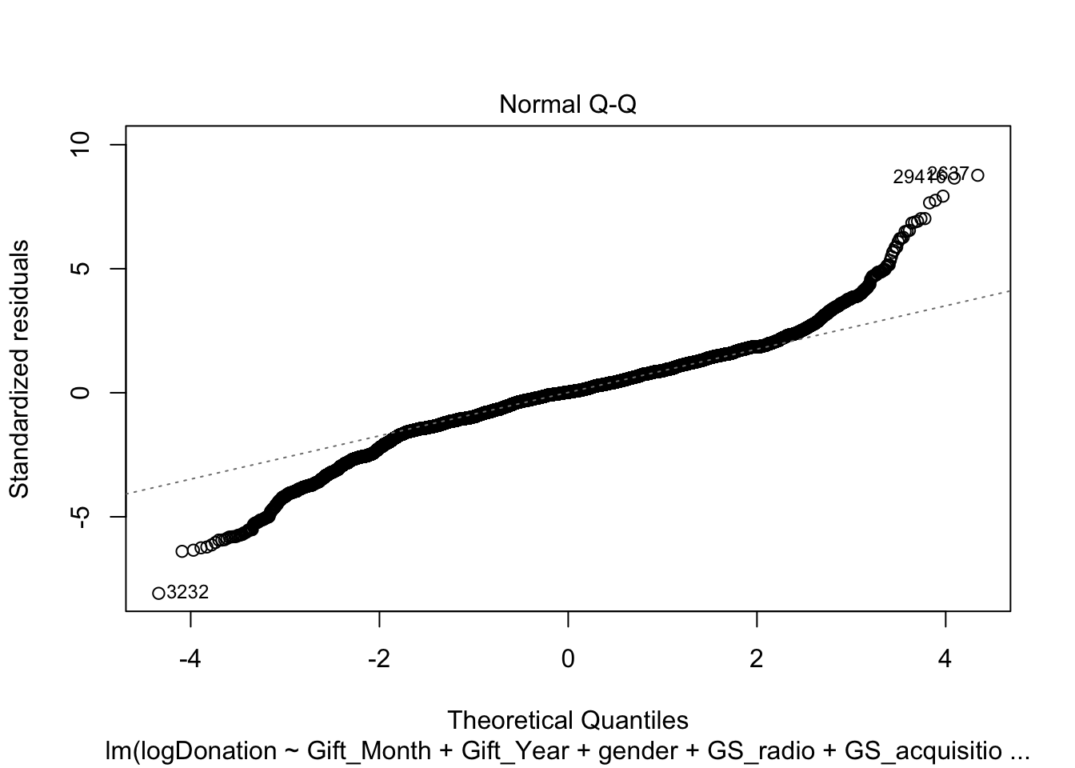





2 models are used for Predictive modelling. The dataset was split into 75% training set and 25% test set. Regression models were built with RMSE as the metric. The models were trained using Regression, Classification Tree, Random Forest, Gradient Boosting, Xtreme gradient boosting and Neural network.



**Figure 14**

The Models were then run with held out test samples as in the right-hand side chart of Figure 14. The box plot on the LHS shows the Root Mean Square Error which is the standard deviation of the residuals i.e. prediction errors.

Gradient Boosted Tree has the lowest RMSE and the best model that can be used for prediction. The R square of 53% is the statistical measure of proportion of variance of the donation that’s explained by the Original Gift Source, Solicitation Methods and other variables as used for regression.

**CONSIDERATION STAGES**



**Figure 15**

Here I am regressing the Mode of payment – EFT, Cash and Credit Cash on various types of gift source.

The cells colored as yellow indicate the significance of the mode of payment used for the gift source.

Greyed out columns show Monthly Credit Card and Quarterly Credit Card are least significant.

One-time Credit Card is the most statistically significant mode of payment.



**Figure 16**

Here I am regressing the variable Original Gift has premium and the gender with Original Gift Source. Original Gift has premium means that when the donor made their first gift, they ask for a thank you gift. We see that statistically the thank you gift is not significant in boosting the donorship. Also, the donation from Male population is also less significant.

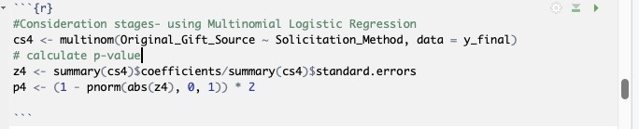

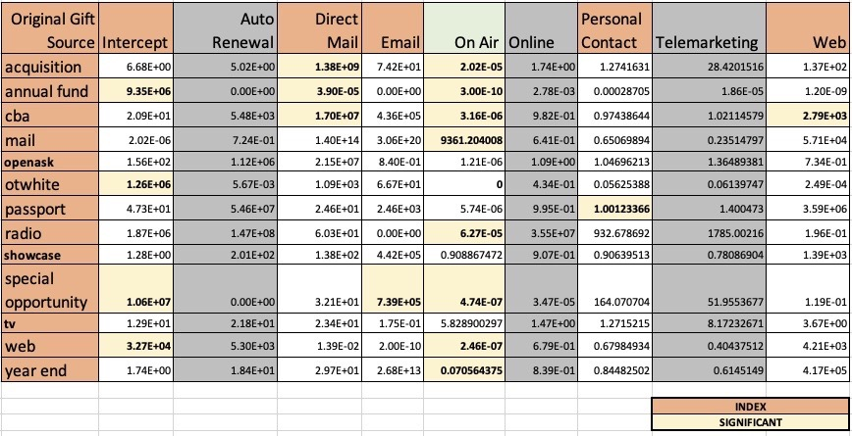

**Figure 17**

Here I am regressing the variable Solicitation Method like Auto Renewal, Direct Mail, Email, On Air, Online, Personal Contact, Telemarketing and Web to test for the significance on Original Gift Source. The greyed-out columns of Telemarketing, Online and Auto Renewal shows that they are not significant. The On-Air seems to be the most significant Solicitation Method in the effectiveness of conversion with Gift source.

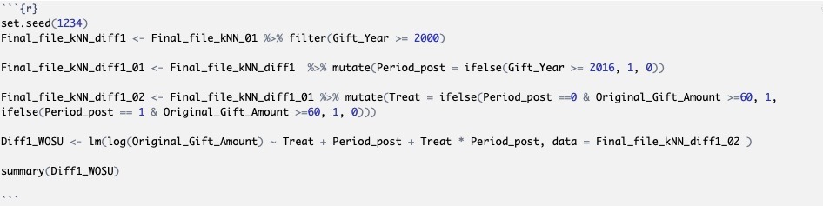

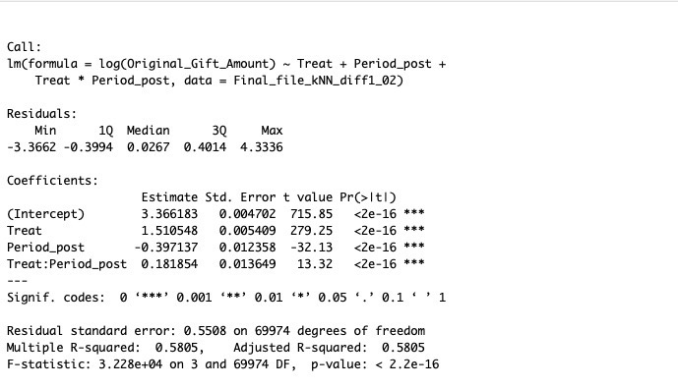

**Figure 18**

In the year 2016, WOSU introduced the Passport as a new member benefit with many privileges for donations of at least $60.00 or more.

So here I am trying to see the difference in donation outcome between the two time periods with the treatment as Passport being introduced.

And the regression has a positive lift of 18.18% of donation, which is differences in differences causal effect.

**PRESCRIPTIVE ANALYSIS**

*Prospects of Donor Expansion*

WOSU Public Media has always excelled in adding value and credibility and it does reflect in the lift in donor database analysis over the years. First time donations are a complement to the sustained and additional planned gift support.

With analysis of the base level data, I have identified opportunities to

- be used in campaign goals

- increase conversion and

- save costs.



**Figure 19**

Figure 19 shows that people prefer Credit Card as the most common mode of payment, and has been proved to be statistically significant. This, in turn, can be interpreted as the fact that a convenient mode of payment can effectively increase the donation conversion. For the non-profit organizations, Text and pay is a very popular feature and can be advantageous to increase the scalability of donations for WOSU.



**Figure 20**

Zooming into the Solicitation methods as in Figure 20, it is clear that more of the first-time donors who had used WOSU’s website has sustained as active donors. Empowering the WOSU website has the potential to increase donor database.



**Figure 21**

Original Gift has premium means that when the donor made their first gift, they ask for a thank you gift. Over the recent years, we see an interesting trend of Donors who do not ask for ‘thank you’ gifts.

In the top right chart of Figure 21, we see the cost rate% of ‘thank you gifts’ on some of the gift sources that are relatively high. And also, in the bottom charts, a greater number of first-time donors have sustained as active donors after not choosing ‘thank you’ gifts, and a greater number of donors have expired who had accepted first time donation gifts.

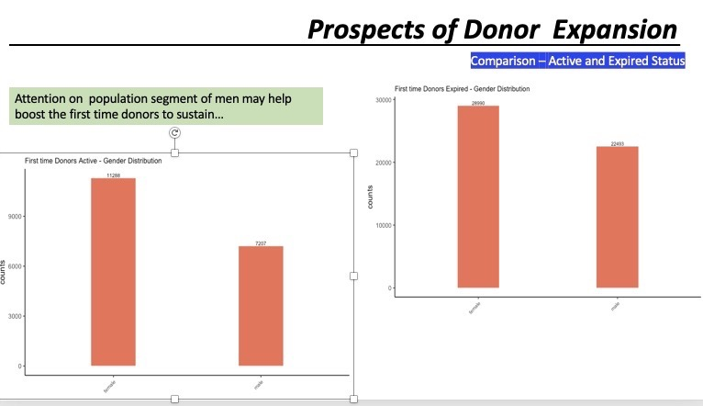

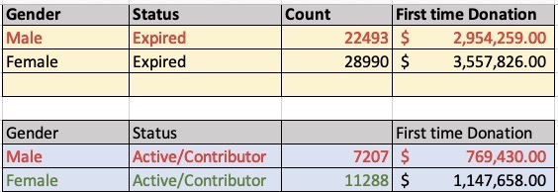

**Figure 22**

In the comparison of Active and expired status of donors in Figure 22, there is a significant decrease in the first-time male donors sustained as in active status as compared to female donors , so is a suggestion to WOSU for consideration in the membership drive.



**Figure 23**

In Event analysis in Figure 23, we observe that more non-donors (about 90%) are participating in the Events.

I see this as a good potential of subjects interested and participating in these events and it will be a good opportunity for WOSU to initiate solicitation or encourage them to participate in a small surveys like conjoint survey.



**Figure 24**

Figure 24 , left chart is a sample of Conjoint Survey .

Conjoint survey helps in discovering the unmet needs or probe into the downstream effect of realization of donations.

The left chart shows the sample of conjoint survey with the Attributes and levels

and the right-hand side chart is a typical decision task given to an individual as a survey.

**Analysis on Organizational First time Donors**

Organizational Donors

z <- GOrg_root_03 %>% select(Gift_Month, Gift_Year, Original_Gift_Source, Solicitation_Method, Original_Gift_Amount, Solicitation_Type )

*#add dummy variables for Original Gift Source*

z_01 <- z %>% mutate(GS_radio = ifelse(Original_Gift_Source == "radio", 1, 0))

z_02 <- z_01 %>% mutate(GS_acquisition = ifelse(Original_Gift_Source == "acquisition", 1, 0))

z_03 <- z_02 %>% mutate(GS_mail = ifelse(Original_Gift_Source == "mail", 1, 0))

z_04 <- z_03 %>% mutate(GS_otwhite = ifelse(Original_Gift_Source == "otwhite", 1, 0))

z_05 <- z_04 %>% mutate(GS_specialopportunity = ifelse(Original_Gift_Source == "special opportunity", 1, 0))

z_06 <- z_05 %>% mutate(GS_yearend = ifelse(Original_Gift_Source == "yearend", 1, 0))

z_07 <- z_06 %>% mutate(GS_newyear = ifelse(Original_Gift_Source == "newyear", 1, 0))

z_08 <- z_07 %>% mutate(GS_showcase = ifelse(Original_Gift_Source == "showcase", 1, 0))

z_09 <- z_08 %>% mutate(GS_passport = ifelse(Original_Gift_Source == "passport", 1, 0))

z_10 <- z_09 %>% mutate(GS_annfund = ifelse(Original_Gift_Source == "annual fund", 1, 0))

z_11 <- z_10 %>% mutate(GS_tv = ifelse(Original_Gift_Source == "tv", 1, 0))

z_12 <- z_11 %>% mutate(GS_web = ifelse(Original_Gift_Source == "web", 1, 0))

*# add dummy variables for Solicitation method*

z_13 <- z_12 %>% mutate(SM_onair = ifelse(Solicitation_Method == "On Air", 1, 0))

z_14 <- z_13 %>% mutate(SM_autoren = ifelse(Solicitation_Method == "Auto Renewal", 1, 0))

z_15 <- z_14 %>% mutate(SM_other = ifelse(Solicitation_Method == "Other", 1, 0))

z_16 <- z_15 %>% mutate(SM_web = ifelse(Solicitation_Method == "Web", 1, 0))

z_17 <- z_16 %>% mutate(SM_directmail = ifelse(Solicitation_Method == "Direct Mail", 1, 0))

z_18 <- z_17 %>% mutate(SM_email = ifelse(Solicitation_Method == "Email", 1, 0))

z_19 <- z_18 %>% mutate(SM_perscont = ifelse(Solicitation_Method == "Personal Contact", 1, 0))

z_20 <- z_19 %>% mutate(SM_online = ifelse(Solicitation_Method == "Online", 1, 0))

z_21 <- z_20 %>% mutate(SM_telemkt = ifelse(Solicitation_Method == "Telemarketing", 1, 0))

z_finalOH <- z_21

Regression model for Original gift source - first time Organizational donors

*#Model_Z10 - include all-y_finalOH*

model_Z10 <- lm(Original_Gift_Amount ~ Gift_Month + Gift_Year + GS_radio + GS_acquisition + GS_mail + GS_otwhite + GS_specialopportunity + GS_showcase + GS_passport + GS_annfund + GS_tv + GS_web + GS_yearend + GS_newyear , data = z_finalOH)

model_Z11 <- lm(Original_Gift_Amount ~ Gift_Month + Gift_Year + + SM_onair + SM_autoren + SM_other + SM_web + SM_directmail + SM_email + SM_perscont + SM_online + SM_telemkt , data = z_finalOH)

Corresponding Bayesian regression - first time Organization donors

n = 91

y <- as.numeric(z_finalOH$Original_Gift_Amount)

Z10 <- cbind(rep(1,n), z_finalOH$Gift_Month,z_finalOH$Gift_Year,

z_finalOH$GS_radio, z_finalOH$GS_acquisition, z_finalOH$GS_mail, z_finalOH$GS_otwhite, z_finalOH$GS_specialopportunity, z_finalOH$GS_showcase, z_finalOH$GS_passport, z_finalOH$GS_annfund, z_finalOH$GS_tv,

z_finalOH$GS_web, z_finalOH$GS_yearend, z_finalOH$GS_newyear )

Z11 <- cbind(rep(1,n), z_finalOH$Gift_Month,z_finalOH$Gift_Year,

z_finalOH$SM_onair, z_finalOH$SM_autoren, z_finalOH$SM_other,

z_finalOH$SM_web, z_finalOH$SM_directmail, z_finalOH$SM_email,

z_finalOH$SM_perscont, z_finalOH$SM_online, z_finalOH$SM_telemkt)

Regression

summary(model_Z10)

##

## Call:

## lm(formula = Original_Gift_Amount ~ Gift_Month + Gift_Year +

## GS_radio + GS_acquisition + GS_mail + GS_otwhite + GS_specialopportunity +

## GS_showcase + GS_passport + GS_annfund + GS_tv + GS_web +

## GS_yearend + GS_newyear, data = z_finalOH)

##

## Residuals:

## Min 1Q Median 3Q Max

## -340.3 -163.9 -51.6 8.2 4570.8

##

## Coefficients: (6 not defined because of singularities)

## Estimate Std. Error t value Pr(>|t|)

## (Intercept) -27259.600 24647.914 -1.106 0.272

## Gift_Month 9.795 17.174 0.570 0.570

## Gift_Year 13.533 12.234 1.106 0.272

## GS_radio 311.540 308.552 1.010 0.316

## GS_acquisition 161.212 410.801 0.392 0.696

## GS_mail NA NA NA NA

## GS_otwhite 238.814 319.915 0.746 0.458

## GS_specialopportunity 116.659 317.292 0.368 0.714

## GS_showcase NA NA NA NA

## GS_passport NA NA NA NA

## GS_annfund 182.789 488.892 0.374 0.709

## GS_tv 276.899 373.351 0.742 0.460

## GS_web NA NA NA NA

## GS_yearend NA NA NA NA

## GS_newyear NA NA NA NA

##

## Residual standard error: 549.9 on 82 degrees of freedom

## Multiple R-squared: 0.04334, Adjusted R-squared: -0.05

## F-statistic: 0.4643 on 8 and 82 DF, p-value: 0.8778

summary(model_Z11)

##

## Call:

## lm(formula = Original_Gift_Amount ~ Gift_Month + Gift_Year +

## +SM_onair + SM_autoren + SM_other + SM_web + SM_directmail +

## SM_email + SM_perscont + SM_online + SM_telemkt, data = z_finalOH)

##

## Residuals:

## Min 1Q Median 3Q Max

## -341.8 -166.7 -64.3 -0.5 4569.3

##

## Coefficients: (6 not defined because of singularities)

## Estimate Std. Error t value Pr(>|t|)

## (Intercept) -25665.90 23770.95 -1.080 0.283

## Gift_Month 12.63 16.45 0.768 0.445

## Gift_Year 12.82 11.85 1.082 0.282

## SM_onair 127.18 120.35 1.057 0.294

## SM_autoren NA NA NA NA

## SM_other -17.75 325.92 -0.054 0.957

## SM_web -167.40 300.93 -0.556 0.579

## SM_directmail NA NA NA NA

## SM_email NA NA NA NA

## SM_perscont NA NA NA NA

## SM_online NA NA NA NA

## SM_telemkt NA NA NA NA

##

## Residual standard error: 541.6 on 85 degrees of freedom

## Multiple R-squared: 0.03795, Adjusted R-squared: -0.01864

## F-statistic: 0.6706 on 5 and 85 DF, p-value: 0.6468

Bayesian

Data=list(y=y,X=Z10)

R = 1000

keep = 20

k = 2 *## Number of independent parameters (beta0,beta1)*

betabar=rep(0,k) *## Zero vector of dimensions equal to the number of independent*

A=diag(rep(0.01,k)) *## Diagonal matrix of dimension k=2. The diagonal elements are 0.1.*

nu =3

ssq = 1

Prior<-list(betabar=betabar,A=A,nu=nu,ssq=ssq)

nprint = 0

out_model_Z10 = runireg(Data,Mcmc=list(R=R))

##

## Starting IID Sampler for Univariate Regression Model

## with 91 observations

##

## Prior Parms:

## betabar

## [1] 0 0 0 0 0 0 0 0 0 0 0 0 0 0 0

## A

## [,1] [,2] [,3] [,4] [,5] [,6] [,7] [,8] [,9] [,10] [,11] [,12] [,13]

## [1,] 0.01 0.00 0.00 0.00 0.00 0.00 0.00 0.00 0.00 0.00 0.00 0.00 0.00

## [2,] 0.00 0.01 0.00 0.00 0.00 0.00 0.00 0.00 0.00 0.00 0.00 0.00 0.00

## [3,] 0.00 0.00 0.01 0.00 0.00 0.00 0.00 0.00 0.00 0.00 0.00 0.00 0.00

## [4,] 0.00 0.00 0.00 0.01 0.00 0.00 0.00 0.00 0.00 0.00 0.00 0.00 0.00

## [5,] 0.00 0.00 0.00 0.00 0.01 0.00 0.00 0.00 0.00 0.00 0.00 0.00 0.00

## [6,] 0.00 0.00 0.00 0.00 0.00 0.01 0.00 0.00 0.00 0.00 0.00 0.00 0.00

## [7,] 0.00 0.00 0.00 0.00 0.00 0.00 0.01 0.00 0.00 0.00 0.00 0.00 0.00

## [8,] 0.00 0.00 0.00 0.00 0.00 0.00 0.00 0.01 0.00 0.00 0.00 0.00 0.00

## [9,] 0.00 0.00 0.00 0.00 0.00 0.00 0.00 0.00 0.01 0.00 0.00 0.00 0.00

## [10,] 0.00 0.00 0.00 0.00 0.00 0.00 0.00 0.00 0.00 0.01 0.00 0.00 0.00

## [11,] 0.00 0.00 0.00 0.00 0.00 0.00 0.00 0.00 0.00 0.00 0.01 0.00 0.00

## [12,] 0.00 0.00 0.00 0.00 0.00 0.00 0.00 0.00 0.00 0.00 0.00 0.01 0.00

## [13,] 0.00 0.00 0.00 0.00 0.00 0.00 0.00 0.00 0.00 0.00 0.00 0.00 0.01

## [14,] 0.00 0.00 0.00 0.00 0.00 0.00 0.00 0.00 0.00 0.00 0.00 0.00 0.00

## [15,] 0.00 0.00 0.00 0.00 0.00 0.00 0.00 0.00 0.00 0.00 0.00 0.00 0.00

## [,14] [,15]

## [1,] 0.00 0.00

## [2,] 0.00 0.00

## [3,] 0.00 0.00

## [4,] 0.00 0.00

## [5,] 0.00 0.00

## [6,] 0.00 0.00

## [7,] 0.00 0.00

## [8,] 0.00 0.00

## [9,] 0.00 0.00

## [10,] 0.00 0.00

## [11,] 0.00 0.00

## [12,] 0.00 0.00

## [13,] 0.00 0.00

## [14,] 0.01 0.00

## [15,] 0.00 0.01

## nu = 3 ssq= 288012.4

##

## MCMC parms:

## R= 1000 keep= 1 nprint= 100

##

## MCMC Iteration (est time to end - min)

## 100 (0.0)

## 200 (0.0)

## 300 (0.0)

## 400 (0.0)

## 500 (0.0)

## 600 (0.0)

## 700 (0.0)

## 800 (0.0)

## 900 (0.0)

## 1000 (0.0)

## Total Time Elapsed: 0.00

out_model_Z10_beta <- as.matrix(summary(out_model_Z10$betadraw))

## Summary of Posterior Marginal Distributions

## Moments

## mean std dev num se rel eff sam size

## 1 -1403.3 5000.9 187.22 1.26 450

## 2 13.0 16.4 0.45 0.67 900

## 3 0.8 2.7 0.10 1.27 450

## 4 4.8 2057.7 66.59 0.94 900

## 5 -172.8 2076.5 67.99 0.96 900

## 6 -238.3 5332.2 171.64 0.93 900

## 7 -53.2 2054.6 67.30 0.97 900

## 8 -168.8 2060.7 66.67 0.94 900

## 9 -257.7 5391.3 165.57 0.85 900

## 10 -119.5 5228.9 200.48 1.32 450

## 11 -122.3 2052.9 65.97 0.93 900

## 12 -36.4 2069.2 65.89 0.91 900

## 13 -187.3 2055.5 65.92 0.93 900

## 14 45.3 5333.7 183.06 1.06 450

## 15 471.8 5154.6 152.50 0.79 900

##

## Quantiles

## 2.5% 5% 50% 95% 97.5%

## 1 -11153.8 -10082.5 -1219.31 6792.4 8141

## 2 -18.8 -14.1 12.71 39.0 46

## 3 -4.7 -3.6 0.74 5.4 6

## 4 -3939.4 -3273.3 -107.64 3294.1 4068

## 5 -4211.7 -3386.1 -242.42 3149.3 4024

## 6 -10773.4 -8970.1 -87.09 8347.4 10162

## 7 -3895.0 -3315.7 -142.97 3317.2 3933

## 8 -4224.7 -3441.1 -263.90 3093.7 3862

## 9 -10938.5 -9521.3 -248.57 8452.2 10429

## 10 -10794.5 -8631.7 -6.41 8184.0 9908

## 11 -4006.5 -3436.0 -221.94 3338.8 3909

## 12 -4049.6 -3374.5 -112.23 3283.3 4011

## 13 -4202.0 -3453.7 -236.88 3273.6 3890

## 14 -10383.0 -8474.7 90.11 8766.8 10805

## 15 -9773.6 -7983.0 702.92 8508.9 9543

## based on 900 valid draws (burn-in=100)

rownames(out_model_Z10_beta) <- c("Intercept", "Gift_Month", "Gift_Year", "GS_radio", "GS_acquisition", "GS_mail", "GS_otwhite", "GS_specialopportunity", "GS_showcase", "GS_passport", "GS_annfund", "GS_tv", "GS_web", "GS_yearend", "GS_newyear" )

out_model_Z10_beta

## mean std dev num se rel eff

## Intercept -1403.2618695 5000.937339 187.2182032 1.2613506

## Gift_Month 12.9585305 16.430178 0.4466675 0.6651608

## Gift_Year 0.7984551 2.730354 0.1026452 1.2719852

## GS_radio 4.8316744 2057.680129 66.5946800 0.9426834

## GS_acquisition -172.7984835 2076.532882 67.9926291 0.9649139

## GS_mail -238.2522536 5332.223985 171.6362961 0.9324896

## GS_otwhite -53.2355515 2054.595481 67.2951469 0.9655113

## GS_specialopportunity -168.7703580 2060.681398 66.6692988 0.9420470

## GS_showcase -257.6591275 5391.329325 165.5682333 0.8487989

## GS_passport -119.5470226 5228.870227 200.4756586 1.3229703

## GS_annfund -122.3053345 2052.888697 65.9738284 0.9295122

## GS_tv -36.3538576 2069.150928 65.8865211 0.9125388

## GS_web -187.3008004 2055.511244 65.9162641 0.9255246

## GS_yearend 45.2887931 5333.707628 183.0633134 1.0601974

## GS_newyear 471.8220441 5154.625535 152.4994657 0.7877437

## sam size

## Intercept 450

## Gift_Month 900

## Gift_Year 450

## GS_radio 900

## GS_acquisition 900

## GS_mail 900

## GS_otwhite 900

## GS_specialopportunity 900

## GS_showcase 900

## GS_passport 450

## GS_annfund 900

## GS_tv 900

## GS_web 900

## GS_yearend 450

## GS_newyear 900

*## plotting examples*

plot(out_model_Z10$betadraw)

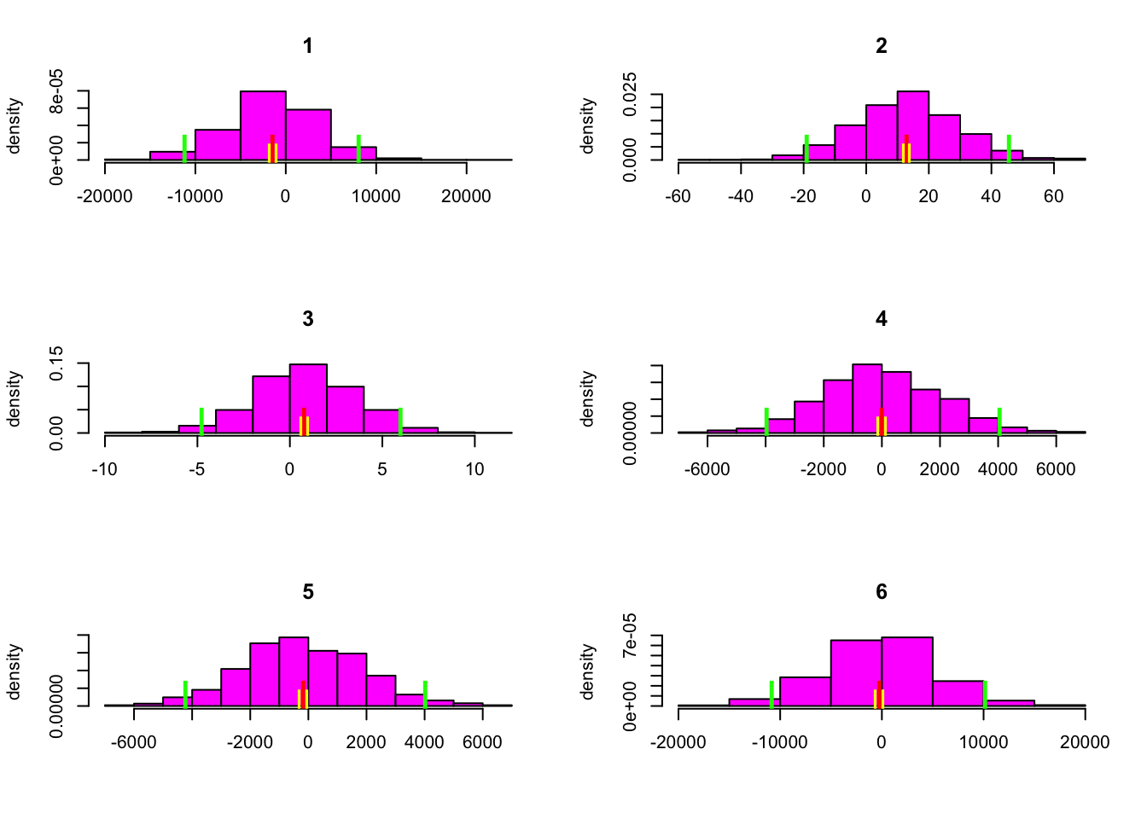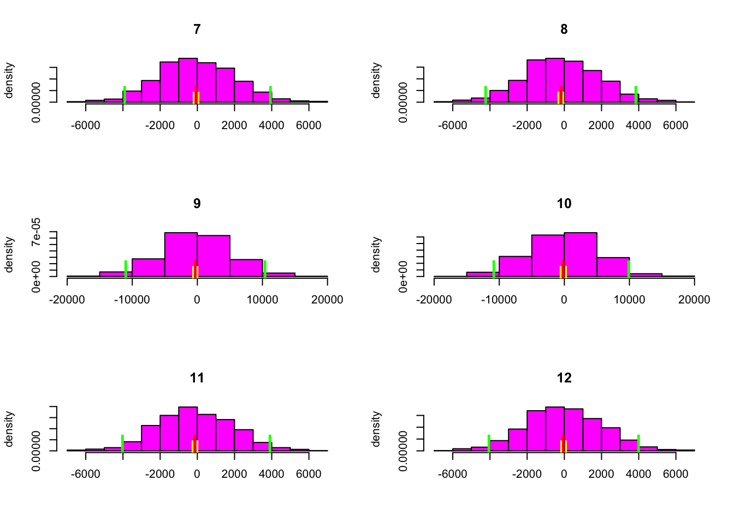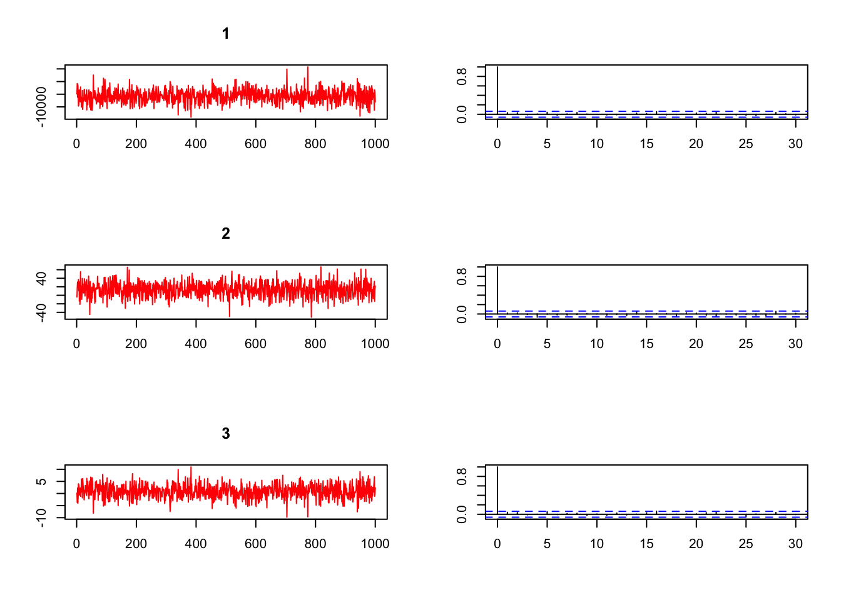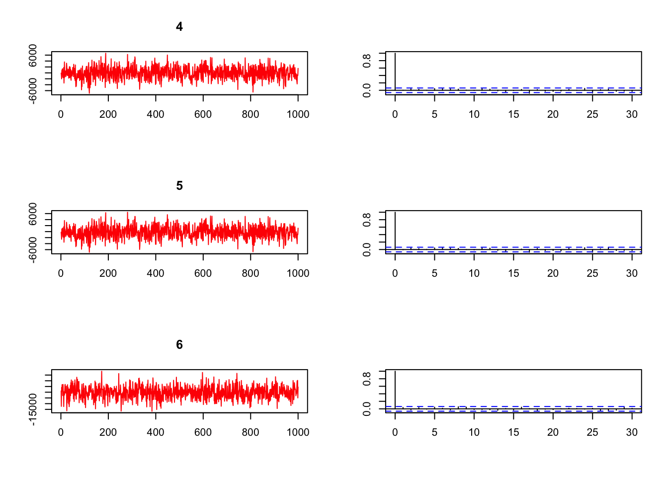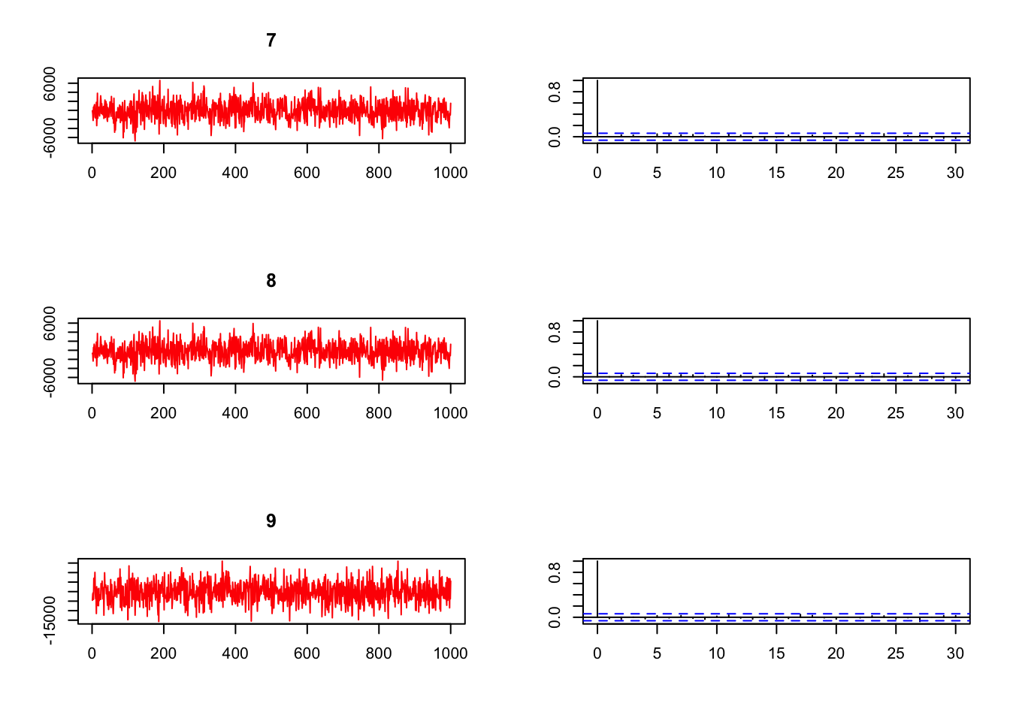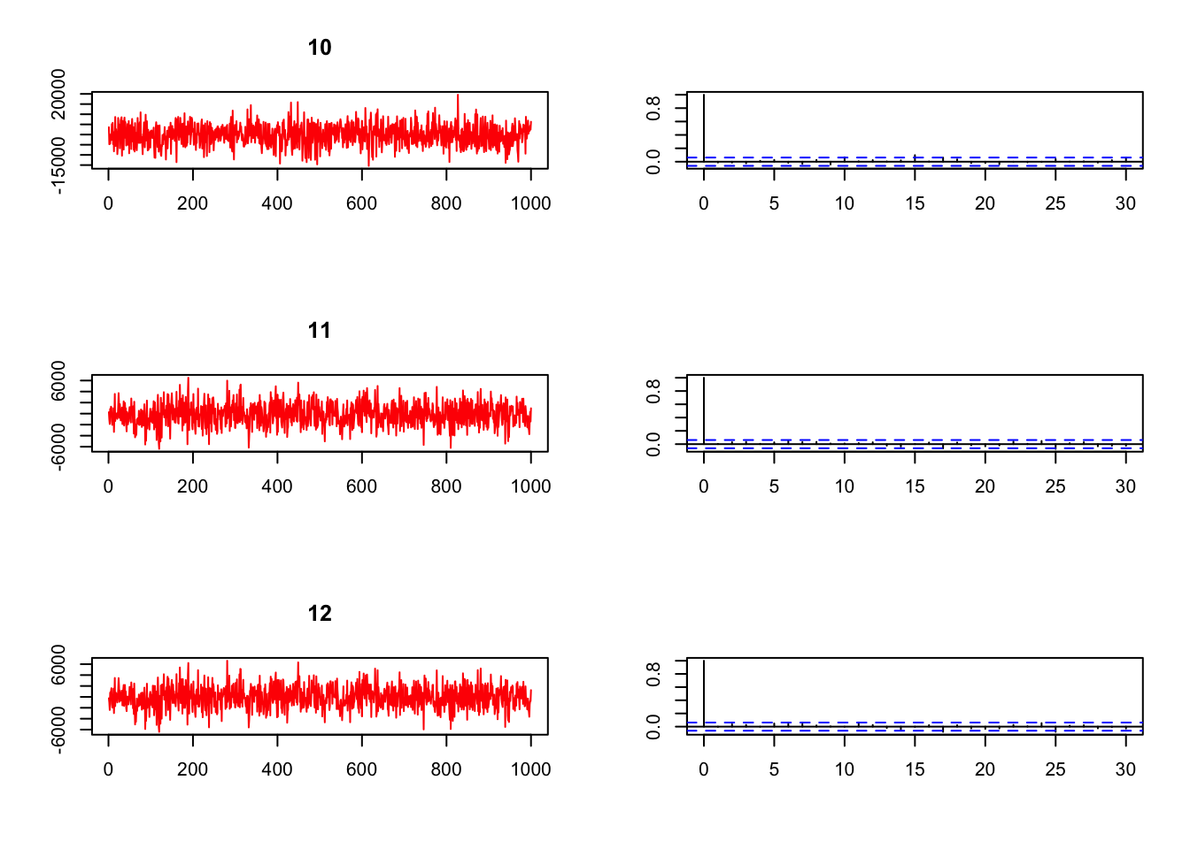

par(mfrow = c(1,2))

draw=cbind(out_model_Z10$betadraw,out_model_Z10$sigsqdraw)

matplot(draw,type="l",col=c(1:4))

**for** (b **in** 1:k){

abline(betabar[b],0,col=b)

}

*# histogram*

par(mfrow = c(1,2))

hist(out_model_Z10$betadraw, breaks = 30,

main = "Beta for Organizations",

yaxt = "n", yaxs="i",

xlab = "Posterior Dist. of Beta", ylab = "", col = "dodgerblue4", border = "gray")

*#########*

Data=list(y=y,X=Z11)

out_model_Z11 = runireg(Data,Mcmc=list(R=R))

##

## Starting IID Sampler for Univariate Regression Model

## with 91 observations

##

## Prior Parms:

## betabar

## [1] 0 0 0 0 0 0 0 0 0 0 0 0

## A

## [,1] [,2] [,3] [,4] [,5] [,6] [,7] [,8] [,9] [,10] [,11] [,12]

## [1,] 0.01 0.00 0.00 0.00 0.00 0.00 0.00 0.00 0.00 0.00 0.00 0.00

## [2,] 0.00 0.01 0.00 0.00 0.00 0.00 0.00 0.00 0.00 0.00 0.00 0.00

## [3,] 0.00 0.00 0.01 0.00 0.00 0.00 0.00 0.00 0.00 0.00 0.00 0.00

## [4,] 0.00 0.00 0.00 0.01 0.00 0.00 0.00 0.00 0.00 0.00 0.00 0.00

## [5,] 0.00 0.00 0.00 0.00 0.01 0.00 0.00 0.00 0.00 0.00 0.00 0.00

## [6,] 0.00 0.00 0.00 0.00 0.00 0.01 0.00 0.00 0.00 0.00 0.00 0.00

## [7,] 0.00 0.00 0.00 0.00 0.00 0.00 0.01 0.00 0.00 0.00 0.00 0.00

## [8,] 0.00 0.00 0.00 0.00 0.00 0.00 0.00 0.01 0.00 0.00 0.00 0.00

## [9,] 0.00 0.00 0.00 0.00 0.00 0.00 0.00 0.00 0.01 0.00 0.00 0.00

## [10,] 0.00 0.00 0.00 0.00 0.00 0.00 0.00 0.00 0.00 0.01 0.00 0.00

## [11,] 0.00 0.00 0.00 0.00 0.00 0.00 0.00 0.00 0.00 0.00 0.01 0.00

## [12,] 0.00 0.00 0.00 0.00 0.00 0.00 0.00 0.00 0.00 0.00 0.00 0.01

## nu = 3 ssq= 288012.4

##

## MCMC parms:

## R= 1000 keep= 1 nprint= 100

##

## MCMC Iteration (est time to end - min)

## 100 (0.0)

## 200 (0.0)

## 300 (0.0)

## 400 (0.0)

## 500 (0.0)

## 600 (0.0)

## 700 (0.0)

## 800 (0.0)

## 900 (0.0)

## 1000 (0.0)

## Total Time Elapsed: 0.00

out_model_Z11_beta <- as.matrix(summary(out_model_Z11$betadraw))

## Summary of Posterior Marginal Distributions

## Moments

## mean std dev num se rel eff sam size

## 1 -1076.22 5292.5 181.732 1.06 450

## 2 16.66 15.2 0.523 1.06 450

## 3 0.76 2.9 0.085 0.78 900

## 4 -270.94 2596.7 59.246 0.47 900

## 5 15.23 5162.5 168.258 0.96 900

## 6 -408.86 2610.8 56.796 0.43 900

## 7 -460.61 2606.5 59.964 0.48 900

## 8 -381.23 2591.6 58.966 0.47 900

## 9 -13.36 5422.7 176.788 0.96 900

## 10 -140.37 5195.8 163.561 0.89 900

## 11 -9.84 5546.4 156.144 0.71 900

## 12 -48.69 5447.3 184.455 1.03 450

##

## Quantiles

## 2.5% 5% 50% 95% 97.5%

## 1 -11954.9 -9956.8 -914.57 7706.1 9238.7

## 2 -12.4 -8.8 16.86 41.3 46.2

## 3 -4.8 -3.8 0.65 5.9 6.5

## 4 -5393.7 -4557.7 -332.76 4089.9 4514.2

## 5 -10420.6 -8459.0 -5.78 8594.8 10452.7

## 6 -5490.9 -4668.7 -373.61 3846.2 4569.8

## 7 -5450.9 -4762.6 -476.87 3833.1 4530.6

## 8 -5389.0 -4730.1 -447.38 3913.9 4534.3

## 9 -10217.9 -8782.1 -198.48 8873.6 10413.1

## 10 -10467.3 -8284.1 -256.30 8487.1 9812.4

## 11 -10366.0 -8958.6 9.40 9796.9 11227.9

## 12 -10099.5 -8609.8 106.76 8706.0 10518.3

## based on 900 valid draws (burn-in=100)

rownames(out_model_Z11_beta) <- c("Intercept", "Gift_Month", "Gift_Year", "SM_onair" , "SM_autoren" , "SM_other" , "SM_web" , "SM_directmail" , "SM_email" , "SM_perscont" , "SM_online" , "SM_telemkt" )

out_model_Z11_beta

## mean std dev num se rel eff sam size

## Intercept -1076.2160043 5292.462192 181.73237527 1.0611862 450

## Gift_Month 16.6649409 15.216137 0.52337417 1.0647761 450

## Gift_Year 0.7563058 2.893406 0.08495322 0.7758601 900

## SM_onair -270.9353887 2596.711428 59.24551523 0.4684962 900

## SM_autoren 15.2343952 5162.459139 168.25768604 0.9560466 900

## SM_other -408.8614712 2610.786234 56.79641964 0.4259335 900

## SM_web -460.6106318 2606.476409 59.96407727 0.4763402 900

## SM_directmail -381.2295296 2591.554524 58.96619742 0.4659379 900

## SM_email -13.3562943 5422.713730 176.78765624 0.9565618 900

## SM_perscont -140.3731282 5195.836837 163.56098575 0.8918482 900

## SM_online -9.8372508 5546.392461 156.14423204 0.7133016 900

## SM_telemkt -48.6880789 5447.301375 184.45526110 1.0319575 450

*## plotting examples*

plot(out_model_Z11$betadraw)

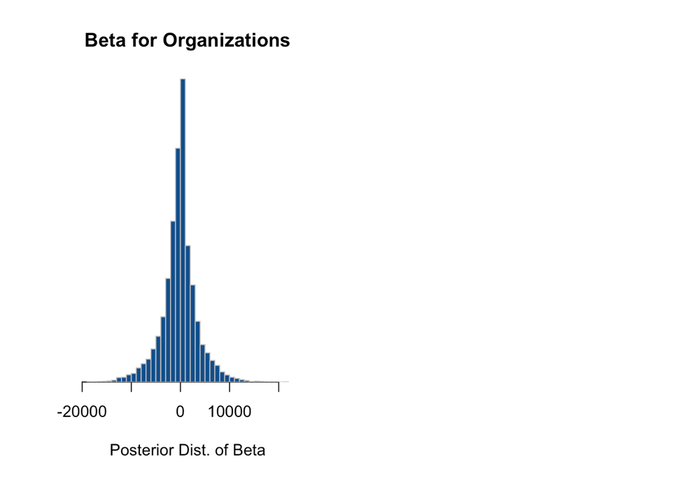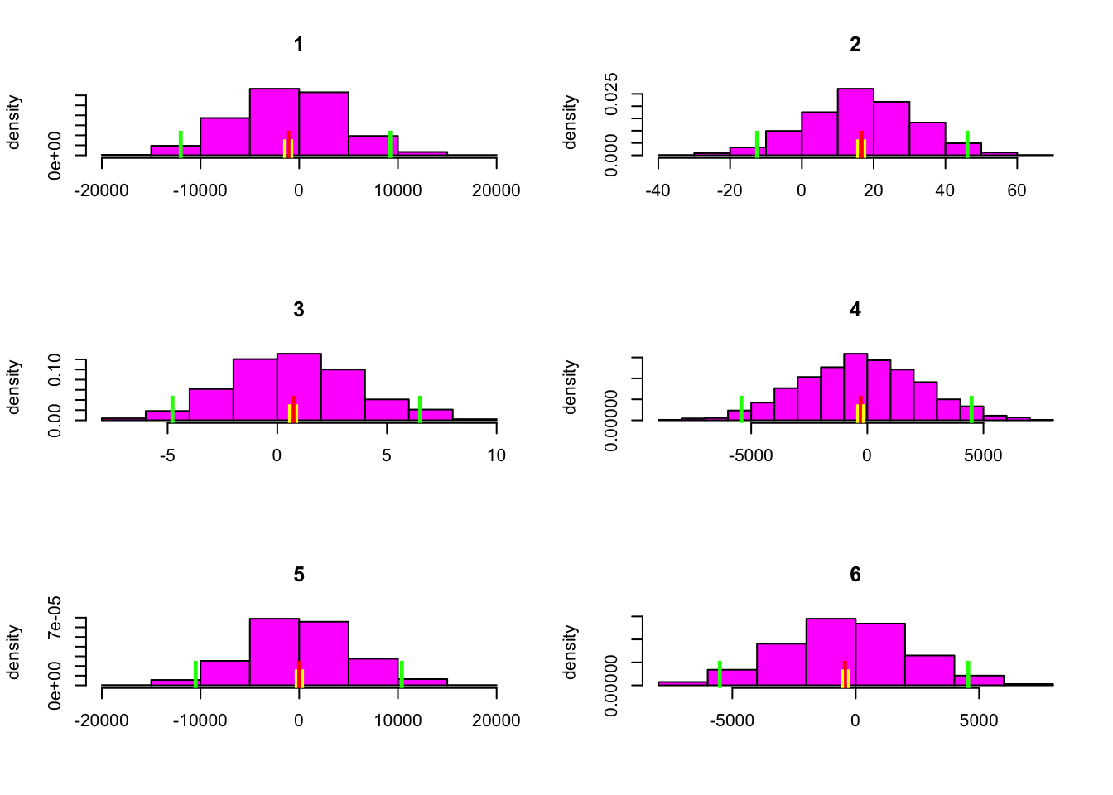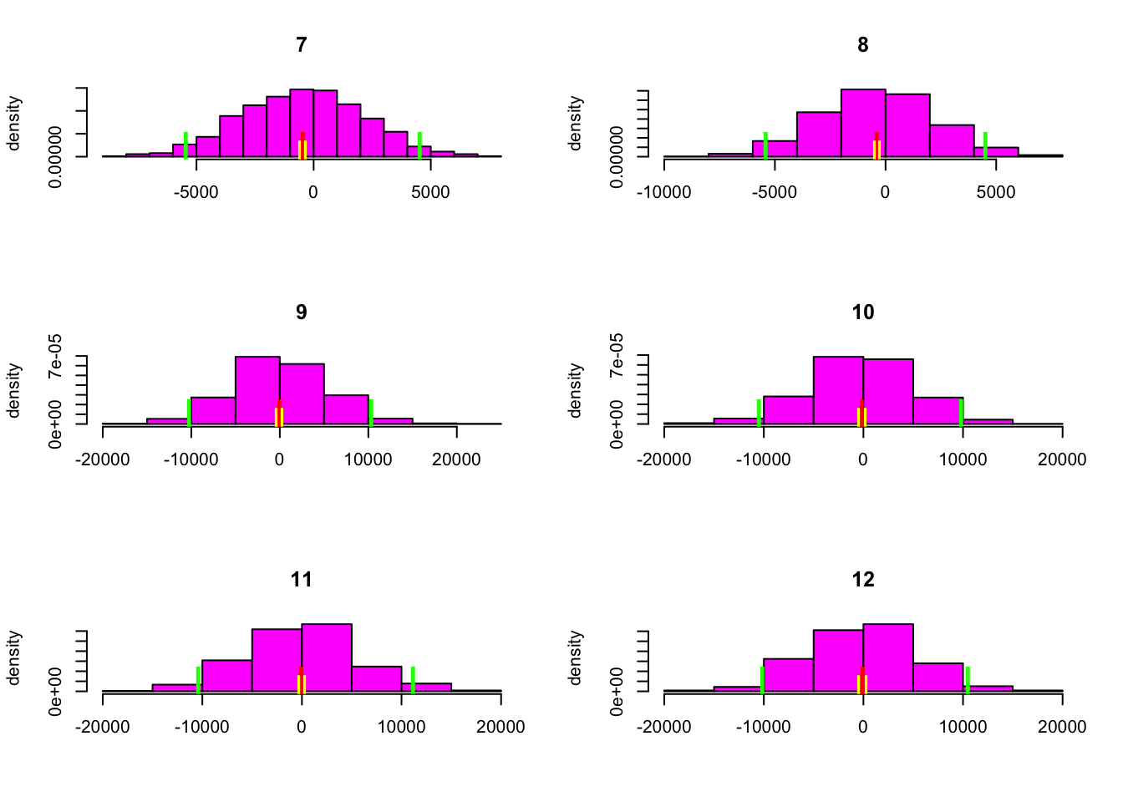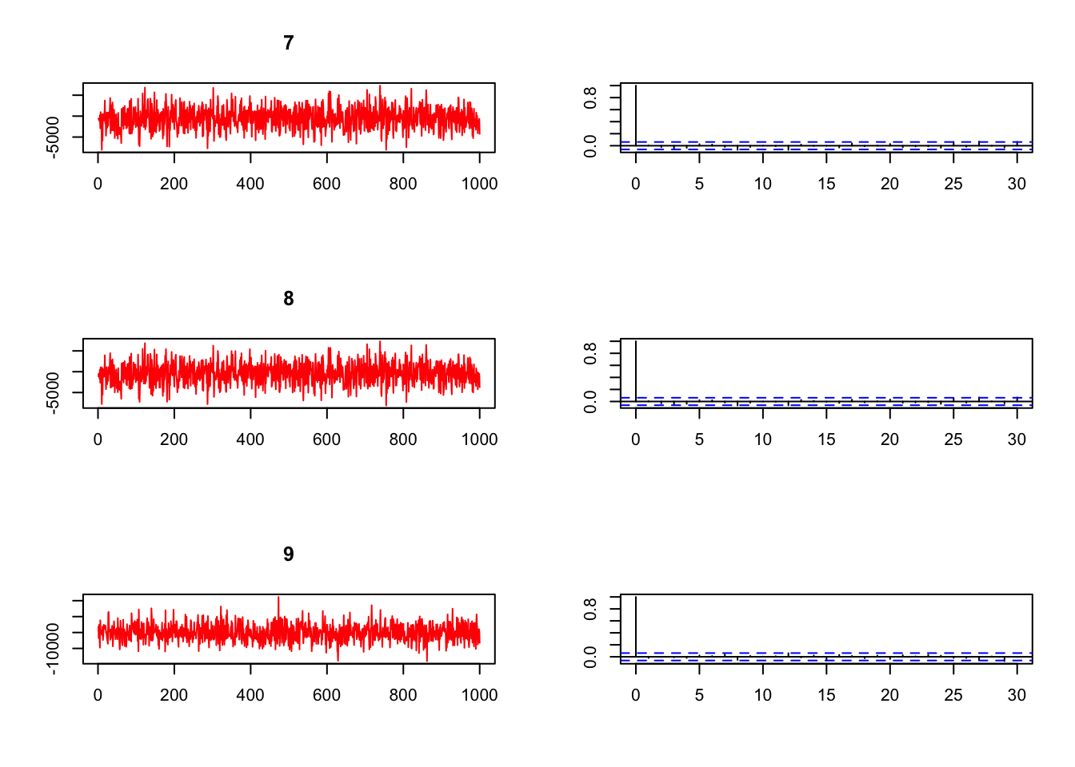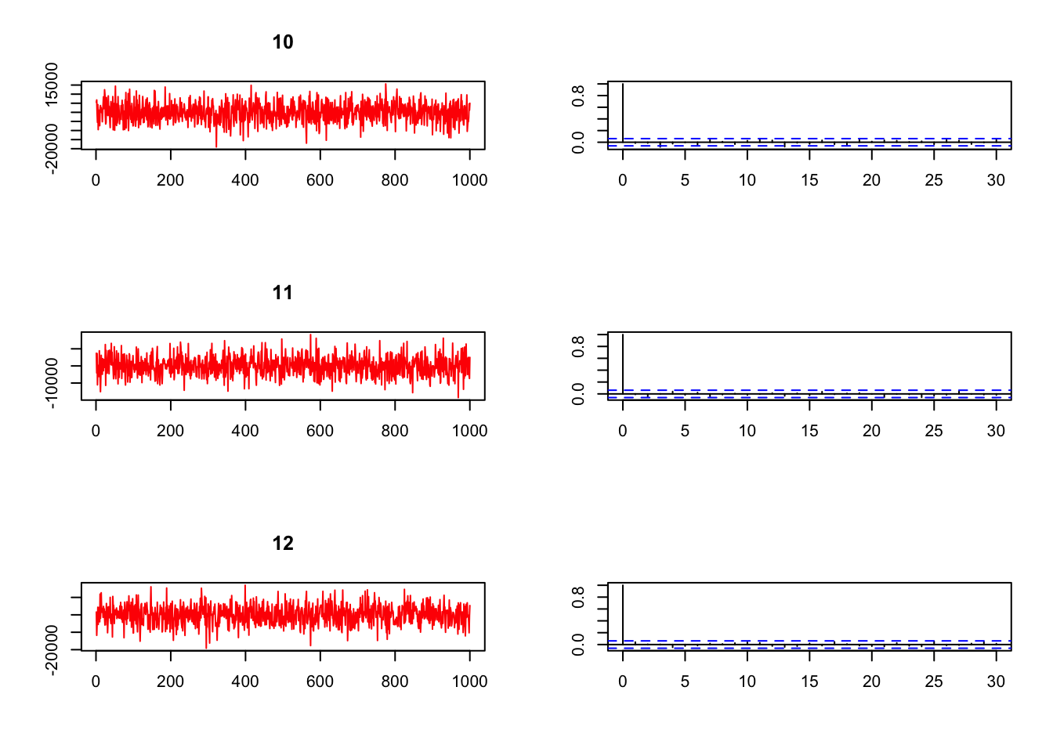

par(mfrow = c(1,2))

draw=cbind(out_model_Z11$betadraw,out_model_Z11$sigsqdraw)

matplot(draw,type="l",col=c(1:4))

**for** (b **in** 1:k){

abline(betabar[b],0,col=b)

}

*# histogram*

par(mfrow = c(1,2))

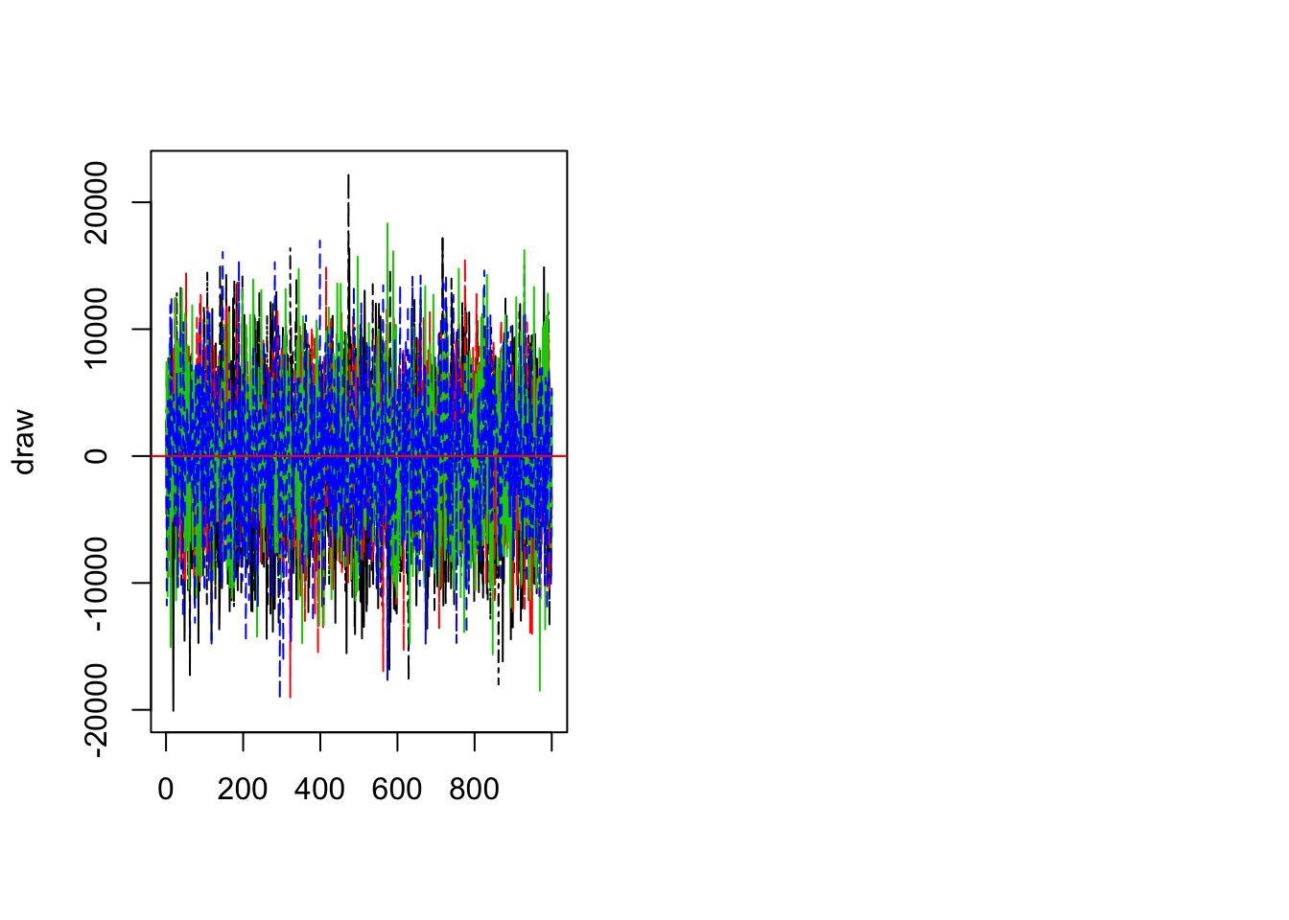

hist(out_model_Z11$betadraw, breaks = 30,

main = "Beta for Organizations",

yaxt = "n", yaxs="i",

xlab = "Posterior Dist. of Beta", ylab = "", col = "dodgerblue4", border = "gray")

Based on the data we have, the Organizational donations seems to have no influence by any of the Solicitation methods or on any Original Gift Source on first time donation. I also tried step-wise regression but the results remained unchanged. Credible interval of the independent variables in Bayes is very large, indicating very less confidence in model parameters. The mean estimates of the posterior also do not lie in the credible interval, and thus is similar to OLS regarding the insignificance of the independent variables.

**Conclusions**

It was overall a very interesting and insightful analysis where I was able to apply Data mining, Descriptive(networks, geo-visualizations, ggplots), Predictive and Prescriptive   analysis and bring about a better understanding with insights into prospective Donor database expansion for WOSU Public media. WOSU as a public media is serving Central Ohio and has always excelled in adding value and credibility and we have seen that in the lift in donations and the donor database in the detailed analysis. First time donors is a complement to sustained donors and additional planned gift support.  In my analysis, I have identified opportunities in strengthening the basis of first time donations

-for campaign goals

-save costs

-increase donor conversions.

Campaign Goals

*Gender Bias*

The analysis (Fig 22) shows that there is a significant decrease in the retention of first-time male donors as sustained active donors as compared to female donors. The regression of gender in Fig 16 on the original gift source also statistically proves that first time Male donors are insignificant in initiating donation.  WOSU can possibly address this in campaign goals in membership drive.

Save C​osts

*Cost-‘Thank-you’ gifts*

It is suggested to consider the provision of the feature of ‘thank you’ gifts for first time donors. The data analysis (Fig 21) has shown an interesting trend recently that more of the donors are not asking for 'thank you' gifts. The cost rate percentage of ‘thank you’ gifts associated with various original gift sources are relatively higher. More of the first-time donors who have not accepted the ‘thank you’ gifts have sustained as active donors. The recommendation to WOSU is to re-evaluate the provision of 'thank you' gifts feature for the first time donors.

Increase donor conversions

*Event-Attendance are non-donors*

Unpacking the Event files (Fig 23), it was interesting to note that more of the non-donors were event attendees. These events are community engagement programs hosted and advertised by WOSU and somehow relate back to their programming. WOSU keeps the list of attendees with their names, addresses, email ids and other event details. I see these non-donor attendees as potential donors, since they are participating out of sheer interest and it is a good opportunity for WOSU to initiate solicitation or encourage them in participating in surveys.

*Surveys*

Conjoint surveys (Fig 24) will help in discovering the unmet needs and focus on the downstream effect of the realization of donations. The answers to the survey questions will aid in adding new meaningful variable to the WOSU donor database  and to know how people value these different attributes and thus will be getting meaningful insights that may help in steering the membership drive and increasing donor database. This will also help in building good and more efficient predictive models  where  variability of the donations  will be well explained by meaningful independent variables.

*Donor’s Mode of Payment*

The Credit Card has been statistically proved to be the most significant in Fig 15. Monthly and quarterly credit card system had the least significance.  This indicates that donors lean towards convenience in mode of payment and one such option of "Text to pay" for non-profit organizations  can  positively increase the scalability of the donations.

*Web-site enhancements*

Web based solicitation methods in Fig 20 has sustained more of first-time donors as active donors, so the recommendation is to empower the WOSU websites as it has a good potential to increase the donor database.  Passport introduced by WOSU in 2016 on its website that had a causal effect of 18.20% lift in donations for every unit of Passport account added as in Fig 18.  On this basis, the recommendation is to add on more website-based initiatives to attract the donors. There is also an option to increase Online donation by adding platforms that use donation tools which customizes the web page to match to the website. Some of the recommended Online Platforms are DonorBox, DonorPerfect, Double the Donation, iDonate, MyPledger etc.

The first-time donor’s retention rate is approximately 26%  as in Fig 9 and this can be significantly improved with various actionable insights  analyzed  to improve campaign goals, save costs and increase donor conversions.

***Key actionable recommendations for WOSU***

* Initiate Quarterly conjoint   surveys to assess  best return ($$) for WOSU membership drive.
* Enhance  WOSU website with new  member benefits  features like Passport.
* Enable 24/7, easy to pay mode of payments (Text and pay, PaypalMobile, ApplePay, Google Wallet).
* Add on Online Platforms with donation tools for non-profit organizations that can customize the pages to match the websites like DonorBox, DonorPerfect, Double the Donation, iDonate, MyPledger etc.

**Drawbacks**

1. The data analysis was done with databases having base line variables and attributes. The analysis would have been more insightful if we had additional  survey data adding more meaningful variables to know how people value these attributes and thus can make Data analysis more organized and interpretative.
2. Very little insights could be drawn with the  Organizational first-time donor data. Bayesian analysis proved that the credible interval of the independent variables were very large, indicating very less confidence in model parameters.
3. The event files with the list of attendees in the events were collected as text files with no formatting. It would be very helpful if the event attendee’s information with first name, last name, address, city, state, zip-code, email id, event name and event date are consistently recorded as formatted files.

***Reference:***

Fundraising Analytics – Joshua M. Birkholz